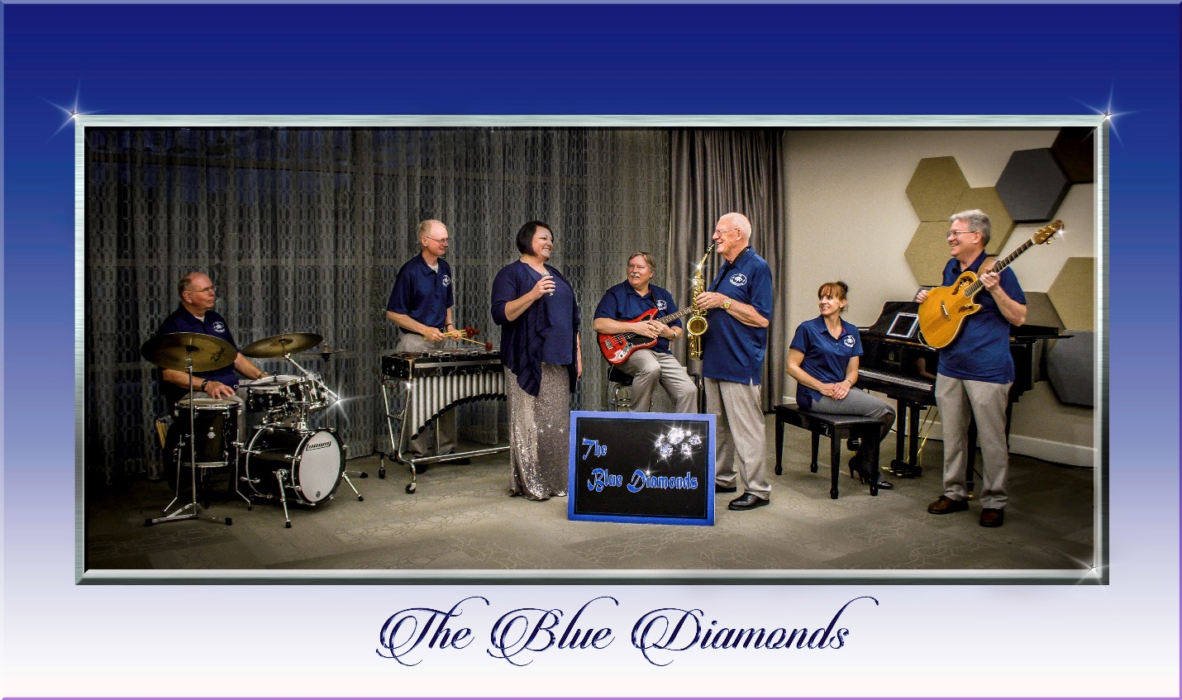

Pricing:
Pricing is for our 7-piece band based in Salt Lake City. We provide our own sound equipment and allow you to use our PA system for announcements, etc. Your guests will be raving about The Blue Diamonds long after your event.
Playing time is the elapsed time the band will play music and does not count the time spent in preparation, setup, tear down, and travel to and from your event. If you book us for more than one hour of playing time, band members will be allowed a 10-minute break each hour. If you want the band to take additional breaks they will be counted as playing time for pricing purposes.
Playing  Time | Salt Lake County Price | Weber, Davis, Morgan, Summit, Wasatch, Utah, and Tooele County Price
1 hours | $400 | $610
2 hours | $750 | $960
3 hours | $1100 | $1310
4 hours | $1450 | $1660

If you would like an individual musician or a small ensemble for ceremony music, please call.
To book the band call Bob Nohavec at (435)-649-6075

